2022
Black Swamp Area
Council

Klondike Derby

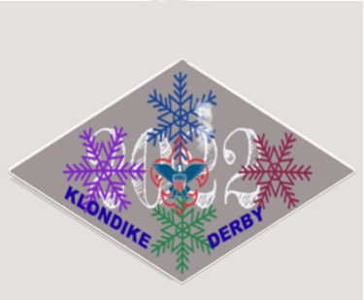

December 2021

Subject: Klondike Derby 2022

Dear Scoutmaster/Crew Advisor,

Excitement is mounting in anticipation of the Black Swamp Area Council Klondike Derby to be held January 15, 2022 at Camp Lakota in Defiance, Ohio. The Klondike Derby Committee has ordered custom designed patches, ribbons and trophies. Mayors have been recruited who have selected events that will test the best of your Troop’s or Crew’s Scouting skills.

Participation in the annual Black Swamp Area Council Klondike Derby will get your Scout Troop and Venture Crew off to a running start for the New Year. Mark your Scouting Calendar now, announce the event at your next Troop meeting and watch the enthusiasm mounts as your Scouts prepare for this great winter event! If your troop is in need of a sled to participate, please contact your District Camping chairman.

Enclosed is the information you will need to prepare your Troop and Crew. The early bird fee is $7.00 per Scout or Venturer. The fee is $10.00 per youth if paid after January 5, 2022. There will be no charge for adult leaders. Troop and Crew rosters will be collected on Derby Day at Camp Lakota. Bring along a personal health and medical summary for each individual. While the Patrols are participating in the Klondike Derby, leaders will be able to enjoy reminiscing with other Scouters at camp. There will also be a trading post available.
Please fill out the pre-registration form enclosed and get set for a great time. If the Derby is postponed due to weather and your unit is unable to attend the alternate date, your pre-registration fees will be refunded.

Yours in Scouting,

Council Camping Committee

KLONDIKE DERBY 2022
A GUIDE FOR TROOPS AND CREWS

WHAT IS THE KLONDIKE DERBY?
In search of gold, the men of Alaska raced across the frozen tundra on sleds pulled by dog teams. Scouts will participate as a patrol, with up to eight Scouts, running an expedition to simulated towns and solving practical problems using basic Scouting skills. (Patrols of less than six boys might find great difficulty in certain events.)

WHEN AND WHERE?
The 2022 Klondike Derby will be held on Saturday, January 15, 2022, at Camp Lakota in Defiance, Ohio. The first group of sleds will leave the starting gate at 9:00 am and the race will be over at 4:00 pm followed by a closing ceremony. Registration and check-in is open starting at 8:00 am.

POSTPONEMENT INFORMATION
Because of the necessity for proper weather for this event, there remains the possibility that it could be postponed. The reasons for postponement would be severe, subzero, arctic weather. However, our “Nanook of the North” has assured us that the weather will be most cooperative.

To verify postponement, you may listen to your local radio station or call the Council Service Center in Findlay 1-419-422-4356. The decision will be made no later than noon on Friday, January 14, 2022. In all cases of postponement, we will move the Derby to the following weekend at Camp Lakota. Please do not call the Camp Rangers.

FEE AND CHECK-IN PROCEDURE
The fee is $10.00 per Scout or $7.00 if paid by the preregistration savings date of January 5, 2022. Registered troops will receive 2 free complimentary patches for leaders. Additional patches may be purchased in the Trading Post if stock allows. Please make checks payable to the Black Swamp Area Council, Boy Scouts of America. If the Klondike Derby is postponed and your unit is unable to attend the alternate date, your preregistration fees will be refunded to you.

Upon arrival at Camp Lakota, proceed to the parking lot as directed. Only special vehicle passes will be allowed outside the parking area (this is for safety reasons.) Patrols should stay together in the parking lot while the Patrol Leader(s) and Unit Leader go to the Ranger’s Compound for check-in.

As part of the registration process, the attached registration roster is to be filled out ahead of time and turned in. The Personal Health and Medical Record for each participant MUST be turned in at the time of registration to the First Aid Attendant (Physician’s signature is not required). These forms should be picked up prior to your unit’s departure.

PREPARING TO START
The Patrols will receive their scorecards and maps at the Starting Line (“Fee’s Landing”). As the Patrols approach the starting line, they will be grouped with other sleds leaving at the same time. The groups will leave in five (5) minute intervals.

All sleds go immediately to “Bear Crossing” (Customs), which will be shown, on the map. Their time will be recorded on the scorecards. After going to “Bear Crossing”, they will go to their first city, and then back to “Bear Crossing” and then to the next city in the order listed on their scorecard. Sleds not following the order of cities on their scorecard will be penalized.

Upon arrival at each city, it is important that they check in with the judge at the entrance gate. He will mark the arrival time when the entire patrol and their sled are present. The sleds will then be parked in the parking area and the Patrol will get the necessary equipment for the event and go to the event area. After completing the event, they will check out with the same judge who will mark their score and the time on the scorecard. The Patrol then returns to Customs then on to the next city on their scorecard.

After going to all the cities, the sled should return to “Bear Crossing” (Customs) to be checked out and then immediately go to “Fee’s Landing’ (Start/Finish Line). Here, the scorecard will be taken and computed and trash bags will be recorded.

KLONDIKE DERBY EVENTS
In preparation for the event, inform all participating patrols that all events require basic Scouting skills found in the Boy Scout Handbook. The Scout Oath and Law will be the policy at all cities and on the trails. Make sure they bring with you and have on their sled, the items listed on page 6. Also, remind them to bring page 12 of this manual with them to the derby.

Special Note:
- Only those Patrols submitting a completed scorecard will be considered as finishing the Derby.
- Patrols entering an Off Limits area will be disqualified from the Derby.

HOW WILL THE SCORING BE DONE?
Your final score will depend on how well your team works the problems and how soon you finish the race. At each city the patrol will be given a score, from 20 to 100, based on how well they complete the activity. In addition the number of minutes the patrol was in the city will be added to the score.

Example: The Fox Patrol spent 18 minutes in Skagway and scored 70 points on the activity. This would give the patrol a total of 88 points for this particular city.

At the end of the day, the total time the patrol was gone from start to finish will be subtracted from the total score earned in all seven cities. This method insures that time spent in cities doing the events or waiting will not be charged against them. Only the time spent going between cities will be charged against their score.

FOOD FOR THE KLONDIKE DERBY
When considering food for your winter Klondike, keep these fundamentals in mind:
- Simplicity of food preparation is the key to success. Cooking in sub-freezing temperatures is difficult at best. Select foods that require little or no cooking, items that can be “cooked” by simply adding boiling water are highly recommended. Many of these items are available in local supermarkets at a much lower cost than the freeze-dried foods sold in sporting goods or outdoor specialty stores. Also consider taking foods that can be eaten cold if necessary. Meals packaged in sealed bag pouches are great. To prepare them you simply drop the entire pouch into boiling water for a specified time, usually five or ten minutes. When they are removed from the hot water, simply tear off an end of the pouch and spoon out the food. The pouch is great for warming your hands, too. Stick to “one pot” menus (stew, chili, casseroles, etc.). Consider precooking raw vegetables. In winter, they require too much time.
- Food for a Klondike needs to be high in calorie value to produce sufficient energy to keep you warm. Carbohydrates and fatty foods are best for long lasting energy. Sugar produces quick energy and is hard on your teeth; prepare your menus with food that “sticks to your ribs”.
- Refrain from foods that will freeze into solid rock; these become impossible to cut. Avoid liquids that will freeze and split or break their containers.
- Use foods that are tasty – ones that most of your group will like. Eating is essential for staying warm, so make eating as pleasant as possible.
- Lunch should be an all-day meal, including items such as granola, raisins, nuts, chocolate, wheat germ, etc.
- Be sure to include plenty of hot drink mix. Instant soups, hot chocolate, and hot Jell-O are popular on cold winter days.
- Develop a written menu for the meal well in advance of your Klondike outing. Using your menu as a guide, develop a grocery list of needed food and supplies. Do not skimp; make sure you are buying plenty of everything.
- Much greater quantities of food and beverages are required for winter camping than for summertime. Your group may require as much as 50% more food to keep warm in winter and perhaps even more than that for severe weather conditions. A generous supply of emergency food should be included in your provisions. Remember that food produces the energy to keep you warm. Have your Scouts eat a good hot breakfast before they arrive.
- Be sure to cover your boiling water to keep a correct temperature.

Sample Menus:
- Precooked Foil Packs- Hamburger (one quarter pound per person), potato, carrots, onions, green pepper, salt and pepper wrapped in aluminum foil.
- Thermos Jug of Chili- have pre-made chili, placed in a thermos bottle so it will keep warm and from freezing.
- Box Soup- makes a fast, hot, inexpensive meal; just add boiling water.
- Gorp- have a mixture of M&M’s, granola, raisins, fruit loops, sugar smacks, dried fruit, mixed nuts, prunes, etc; or another high energy meal in a plastic bag for fast snacking.

Keep in mind that your food and water will freeze fast if not properly packaged.

LUNCH ON THE TRAIL IS ONE OF THE REQUIREMENTS OF THE EVENT. The lunch is at the discretion of the Patrol and Troop leadership; however, each Patrol should plan to have at least a hot drink. No ground fires will be allowed. Low impact (Leave No Trace) camping rules will apply.

A signal (Klondike Cannon) will be sounded at 12:00 noon. The sled will stop at this point and fix lunch. It will stay at that point until the next signal is fired at 1:00 pm. ONLY ONE HOUR IS ALLOWED FOR LUNCH AND CLEAN UP. Scouts are on their honor to remain in the same spot from the beginning to end of the lunch period. The Patrol must thoroughly extinguish the fire and clean up any paper or other material used during lunch. The complete fire residue must be collected and placed in the plastic bag (Leave No Trace principles apply!) and returned to Fee’s Landing. Make sure the fire is completely extinguished before placing ashes in the bag!

SLED DESIGN
As part of this brochure, there is a sled design to be used by each Patrol; the sled must closely resemble this design and the Judge’s decision at Fee’s Landing is final. New sleds will receive a special ribbon. Wheels cannot be used on sleds (sleds must remain on the ground at all times).

SNOWMOBILES, TRAIL BIKES, ETC.
Snowmobiles, trail bikes, or other off-road vehicles are not permitted on the Lakota Scout Reservation.

AWARDS/CLOSING CEREMONY
- Each Patrol making a new sled will be given a special ribbon.
- All Patrols will receive a participation ribbon.
- Each Scout will receive an official Klondike Derby patch.
- The traveling trophy will be presented to the Patrol with the highest score. This large trophy would make a fine addition to your troop meeting room.
- Recognition of the first ten places will be given at the closing ceremony.

SOUVENIRS
At the Registration, extra Klondike Derby patches, if available, will be available for purchase.

VISITORS
Visitors are welcome and encouraged to attend the Klondike Derby. Because of its high visibility, this event is an excellent opportunity for parents, Cub Scouts and interested citizens to see Scouting in action. Visitors are welcome to visit cities. Visitors, including Scout Leaders and Scouts, are to be in the registration area only on official business.

CONDUCT
The Scout Oath and Law will be the rule of the Derby; as in any Scouting event. While on their own going from city to city, the Patrols should follow the rules of outdoor conduct and the principles of Scouting. Scouts are reminded there will be no intentional ramming of sleds allowed at the Derby; anyone caught interfering with another sled will be immediately disqualified. Claim jumping is also forbidden; violators will be disqualified. No Patrol flags are to be stolen, violated, or damaged – perpetrators will be disqualified.
There may be situations that arise in the cities or other locations of the Derby where decisions must be made which are not covered in this guidebook; these decisions will be made by the members of the Klondike Derby Committee and will be final.

EQUIPMENT REQUIRED BY EACH PATROL
The equipment required on each sled falls into three general categories: 1) materials needed for specific events; 2) materials normally useful during an outing and, 3) appropriate clothing for outdoor winter activities is a must; Scouts will be inspected for proper clothing. Additional items may be carried by a Patrol; this list is only the minimum mandatory required items.

MANDATORY EQUIPMENT
- A sled of at least five and one-half feet long and fifteen inches wide with the Troop number on the side (a must).
- A Patrol flag attached to the sled.
- A notebook and pencil per sled.
- A low impact method for cooking your lunch.
- Cleanup materials for cooking.
- Hot drinks in quantity enough for each Scout.
- One cup per Scout.
- Food for the noon meal.
- One compass per Patrol. (Scouts must know their pace).
- A Patrol first aid kit.
- *Waterproofed matches.
- One poncho or rain gear per Scout.
- A pot to cook the hot drinks in.
- Boots on every Scout. (See note below)
- Gloves for every Scout.
- *One Pocketknife/Scout.
- *One Hand axe per Patrol.
- One clipboard per Patrol.
- Two garbage bags.
- Two blankets per sled.
- One Boy Scout Handbook per sled.
- One piece of 2” x 4” x 18” uncut wood.
- Six pieces of ¼” rope each 8 feet long.
- Three pieces of ¼” rope each 15 feet long.
- Three (3) Scout staves each 6 feet long.

*Totin Chip & Fire Chit cards will need to be shown by each participating Scout.

SCOUTS WEARING TENNIS SHOES ONLY WILL NOT BE PERMITTED TO PARTICIPATE IN THIS ACTIVITY.

SLED DESIGN

This drawing will give you an idea of what kind of sled you can build. The use of varnish or wax on the runners will give you greater speed. Your troop number should be prominently displayed on the sled. See mandatory item on page number 5 of this manual.

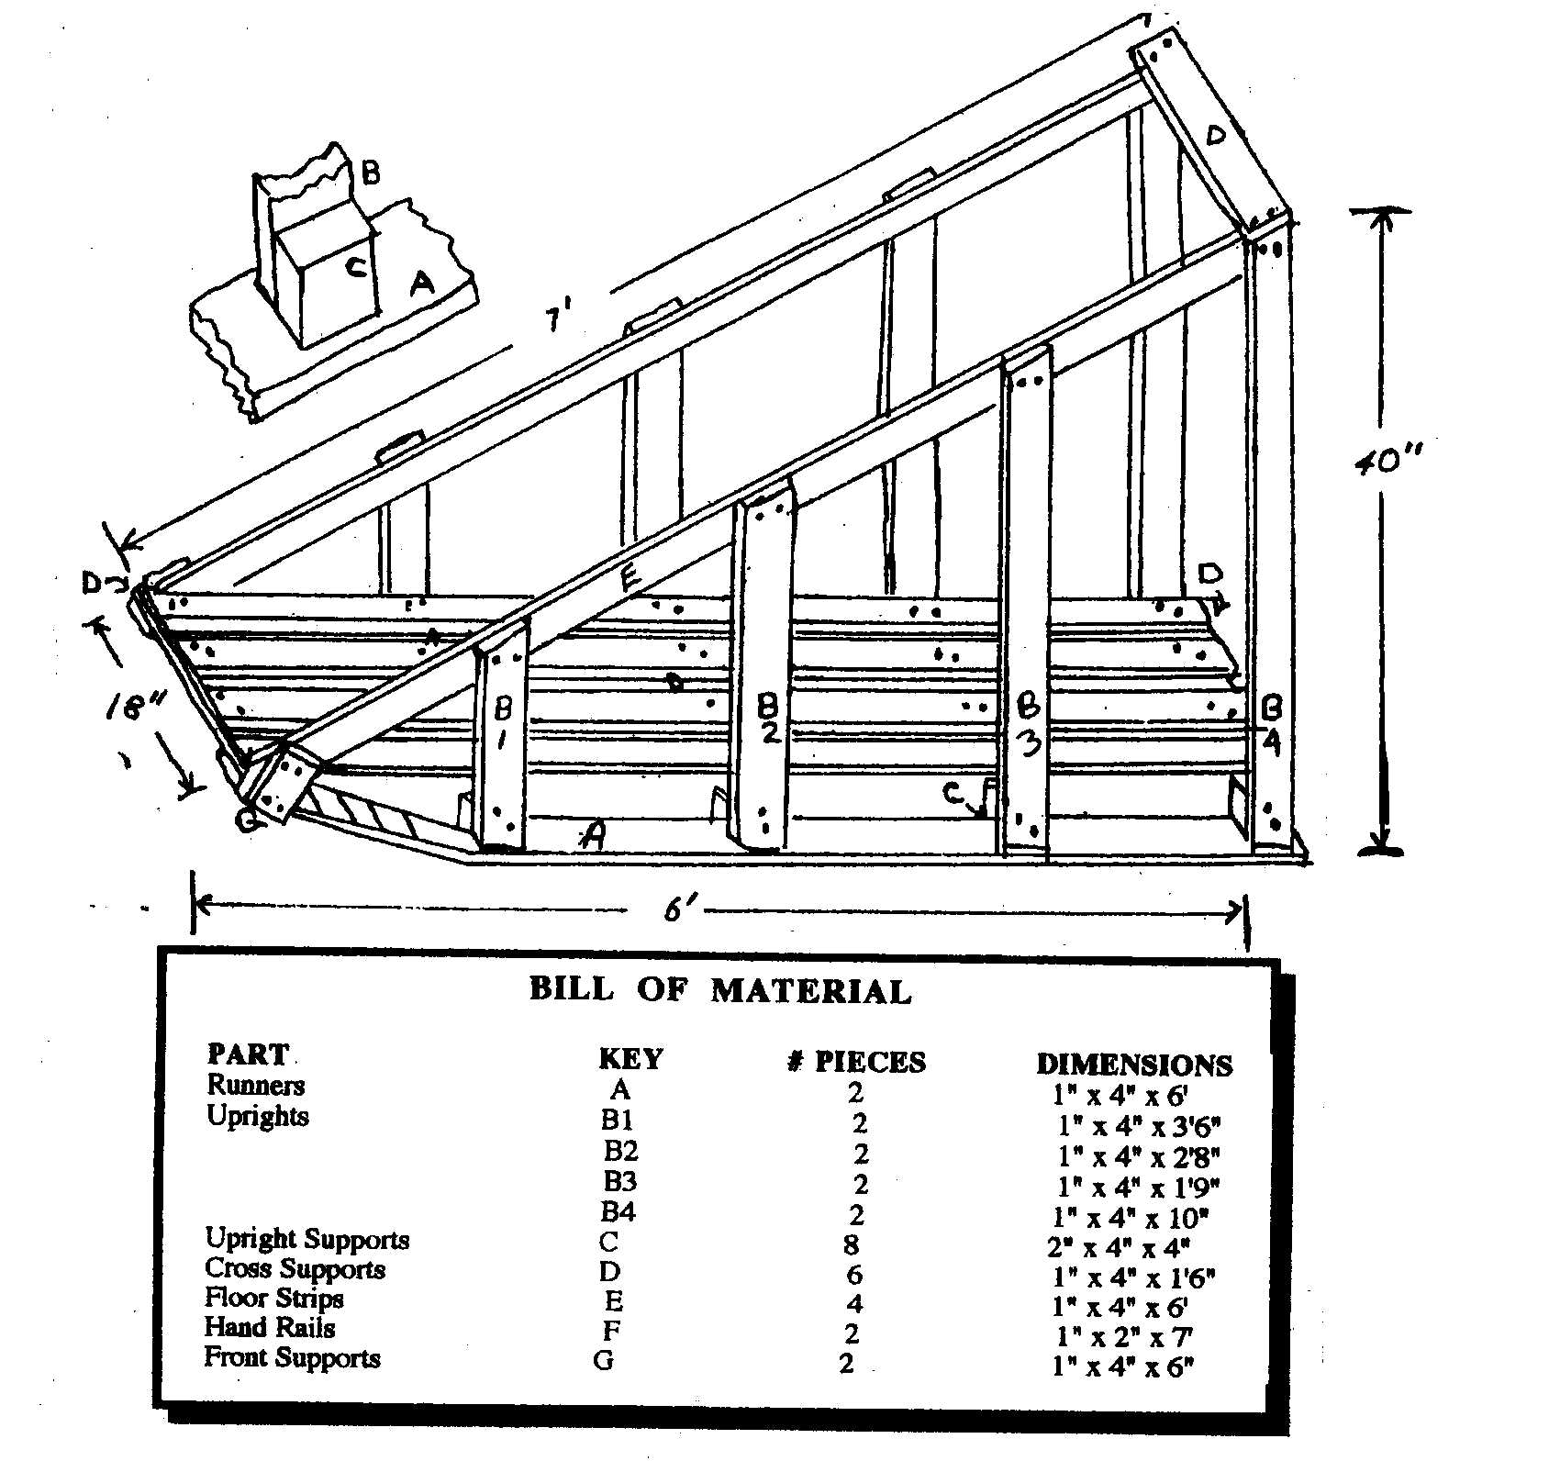

How to Build and Use a Sawdust Stove
By B.R. Saubolle, S.J.
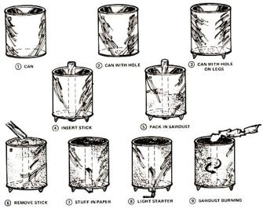
One of the simplest fuels for cooking and for heating the house in winter is sawdust . . . a waste product which is usually thrown away and which, therefore, is obtainable free or at nominal cost. (True, not everybody lives conveniently near a sawmill or lumberyard, but the same objection applies to many other alternative sources of power. Not everyone has a stream running through his property to generate electricity, or keeps cattle to supply manure for methane. We must make use of whatever resources are available to us.)
Sawdust will burn properly only in a specially constructed stove, which is very simple to make and costs practically nothing. The fuel always lights with only one match in such a unit, and can be kept ablaze for long periods—six, eight or even twelve hours if desired—with absolutely no smoke, no blowing or fanning and no refueling.
Once lighted, such a stove burns until all the fuel it contains is consumed. It can then be recharged and lighted again. Such a device is ideal where steady heat is required for hours on end with no attention (to provide day-long hot water, for instance, or to keep a sickroom cozy and warm through a chill winter's night).
To make a sawdust stove, take a large paint can, remove the top and cut a two-inch hole in the middle of the bottom. Set the container up on three legs, and the stove is ready. The only "tool" you'll need to make your burner work is a smooth round stick or length of water pipe which will fit through the hole in the bottom of the can. It should be long enough to protrude four inches above the can's top edge when the shaft is passed vertically through the stove and its lower end rests on the ground.
It is absolutely essential that the fuel for this stove be bone dry. If it's slightly damp, it will smoke. . . and if it's very damp it won't light at all. Dry sawdust burns wonderfully well—sometimes even with a blue flame—and is entirely smokeless. It does give off some fumes, however, and the room where the stove is in use must be well ventilated.
To load the burner, insert the stick or pipe through the hole in the bottom of the can and hold the shaft straight up while you pour sawdust around it. Every now and then, as you fill the container, press the fuel down—the harder the better—to make it tight and compact. When the can is full, completely cover the top of the sawdust with a thin, even layer of sand or ashes. Then twist the pipe back and forth and carefully pull it out of the packed fuel. You'll have a neat hole—which will act as a chimney—right through the mass.
The sawdust stove is easy to light. Just crumple a sheet of newspaper accordion-fashion and push it gently down the chimney until it protrudes at the bottom. Put a match to the lower end, and the homemade heating unit will require no further attention whatever until the fuel is completely consumed.
The powdered wood burns from the center outward, the hole gradually increasing in diameter until there is no sawdust left and the flame dies out. The rate of consumption is about an inch and a half to two inches per hour (the figure varies slightly with the quality of the fuel and how tightly it's packed). A stove one foot in diameter will burn about six hours, and one eight inches across will operate long enough to cook a meal and produce some hot water to wash the pots and pans.
The amount of heat produced is regulated by the depth of the container: the longer the chimney, the hotter the flame. A tall, narrow stove will become very hot for a relatively short time, a broad, squat model will give a gentler heat for a longer period and a tall, wide drum will burn both long and hot. Calculate the dimensions to suit your requirements.

EMERGENCY HYPOTHERMIA KIT
A good hypothermia kit to keep in your car for winter travel should include the following:
- Waterproof matches and fire starter
- Compass and maps
- Fueled stove, cooking pot, and food
- Sleeping Bag
- Flashlight, flares, and candle
- Waterproof insulated ground cover
- Rain gear
- Water container
- Pocket knife
- Extra warm clothes

Avoiding excessive heat loss prevents hypothermia. This can be done by:
- DRESSING TO KEEP WARM
- Wear a cap of some type. Approximately 40% of body heat is lost through the head and neck. In strong winds and/or wet weather, a head cover permanently attached to a jacket that also protects the neck is best. REMEMBER TO KEEP YOUR HEAD COVERED.
- Cover the extremities. Wear long sleeve shirts and pants, gloves, jacket or sweater. Several layers of thinner clothing are better than one thick layer. It is easier to control your body temperature by adding and removing layers of thin clothing.
- Give consideration to wool clothing. Wool retains 30 to 40 percent of its insulating powers when it is wet. Synthetic materials and cotton lose nearly all of their insulation capability when wet. Cotton acts like a wick and will draw moisture.
- In windy weather, wear a garment (windbreaker) to prevent heat loss by convection.
- DRESSING TO KEEP DRY
- Clothing must be kept dry to maintain its insulating abilities. Rain gear that covers all extremities, jacket and trouser style is better than ponchos. Leggings and waterproof jacket are excellent. Waterproof materials that “breathe” are best because they permit the evaporation of perspiration at a moderate rate and help to prevent getting wet from perspiration. Thin plastic that is easily damaged is not reliable. The purposes of keeping dry is to:
ALLOW CLOTHES TO MAINTAIN THEIR INSULATING ABILITY
KEEP COLD WATER AND MOISTURE AWAY FROM YOUR SKIN
Special care must be taken to keep cotton, synthetic materials, and goose down dry. Goose down loses nearly all of its insulating ability when it is wet and it can take days before it is completely dry again.
- AVOID CONTACT WITH COLD OBJECTS
- AVOID SWEATING

A SPECIAL DANGER – EATING SNOW
The dangers of eating snow or ice deserve special attention. The amount of heat required to convert one ounce of snow or ice at 32 degrees F into one ounce of water at 32 degrees F is the same amount of heat required to raise the temperature of one ounce of water from room temperature to boiling. That is, heat is required just to convert ice or snow to water without raising its temperature. If you eat ice or snow, the heat required to do this melting comes from your body. Eating snow or ice promotes hypothermia.

WATER
It is important to drink adequate amounts of water in cold windy conditions.

WELCOME TO THE 2022 KLONDIKE DERBY
(TAKE THIS PAGE WITH YOU ON THE KLONDIKE TREK)

The Klondike Derby Committee welcomes you to the 2022 Klondike Derby, and wishes you the best of luck as you and your Patrol participate in this exciting winter event. The following information will help your Patrol have a better time during the day and guarantee fairness for all.

Starting Procedures:
- When you checked in, you were given a card to fill out. Please fill it out and turn it in at the sled inspection area.
- After leaving the registration area, your Patrol must stay in line with your sled. As you approach the inspection line, you will be placed in position. YOU MUST STAY IN LINE.
- After sled inspection, you will be instructed to move to the starting line where you will be given a packet containing instructions, scorecard and a map. SAFE GUARDS THESE ITEMS!
- From the starting line, you will go to Bear Crossing (Customs) and from there to your first city as listed on the scorecard.

Order of Cities:
Cities are printed in a certain order. After going to Customs, you will go to your first city, then back to Customs and then to the next city in the order listed. You will lose points if you do not follow these directions.

Procedures at Cities:
Upon arrival at the cities, you will check in with the official at the gate. The entire patrol must be present to check in. He will mark your entry time and give instructions for that event. You will then park your sled in the designated place and gather all the equipment necessary for the event. You will then go to the “Mayor’s Office” to be assigned a judge. After you have completed the event, you will check out with the same judge that checked you in. He will mark the time on your scorecard.

Lunch:
At the sound of the Klondike Derby cannon at Noon, you MUST STOP WHERE YOU ARE and have lunch. The only exception to this will be if you are checked into a city at that time. In this case city officials will give you direction. You are on YOUR HONOR to remain in that location until the signal is sounded (Klondike Cannon) at 1:00 pm. Lunch is from 12:00 Noon until 1:00 pm.

Finish:
Once you have finished the course and have been to all seven (7) cities, you return to Bear Crossing and then to the finish line. There you will turn in your scorecard and have it marked with the finish time. Bring your garbage bag with your trash from lunch and the remains of your fire and have it checked for points. You must take the garbage bag home – you are on YOUR HONOR to do this. The judges will then compute your score.
The derby will officially end at 4:00 pm. A Closing Ceremony will be held following the tally of scores. The Closing Awards Ceremony will be held on the deck at the Training Center.

Conduct:
As you are on the trail, you will conduct yourself in a Scouting manner. Leave all other sleds and Scouts alone. In case of questions or problems, contact a City Mayor. Miscellaneous Information:
- All injuries must be reported to the First Aid Station.
- Your Patrol flag is to be securely tied to your sled.
- Adults with sleds: Any adult found coaching, advising, or aiding the Scouts in any manner (except under emergency conditions) will cause that sled and team to be disqualified.
- No two-way communications devices will be allowed – let’s give everyone a fair chance.
- Scoutmasters and Senior Patrol Leaders will be responsible for all listed materials on sleds. All sleds will be inspected prior to the start.
- As your Patrol starts on your adventure, we wish you the best of luck.

Have Fun!
The Klondike Derby Committee

KLONDIKE DERBY 2022

Registration Sheet

Scoutmaster/Crew Advisor – Please fill out and present this form to Klondike Headquarters at Camp Lakota, Defiance, OH, on Saturday, January 15, 2022 upon check in. Please print in ink.

Troop/Crew # __________ District ______________________________ Town _________________________

Scoutmaster/Advisor Name ___________________________________________________________________

Number of Patrols ________________Total Scouts Participating _____________ Adults ______________

(Please put emergency phone numbers after each Scout’s name)

Patrol Name___________________________
1.____________________________________
2.____________________________________
3.____________________________________
4.____________________________________
5.____________________________________
6.____________________________________
7.____________________________________ 8.____________________________________ 9.____________________________________
10.____________________________________

Patrol Name___________________________
1.____________________________________
2.____________________________________
3.____________________________________
4.____________________________________
5.____________________________________
6.____________________________________
7.____________________________________ 8.____________________________________ 9.____________________________________
10.____________________________________

Patrol Name___________________________
1.____________________________________
2.____________________________________
3.____________________________________
4.____________________________________
5.____________________________________
6.____________________________________
7.____________________________________ 8.____________________________________ 9.____________________________________
10.____________________________________

For Official Use Only:

Pre-registration fees: _____________
Walk-In fees: ___________________
Total Fees: _____________________

Check # ___________ Amount # ____________
Cash Payment #__________________________

---------------------------------------------------------------------------------------------------------------------------------
Please indicate those adults who will be assisting in Klondike cities:

NAME CITY MORNING AFTERNOON
1.___________________________________________________________________________________
2.___________________________________________________________________________________
3.___________________________________________________________________________________
4.___________________________________________________________________________________
5.___________________________________________________________________________________
6.___________________________________________________________________________________

